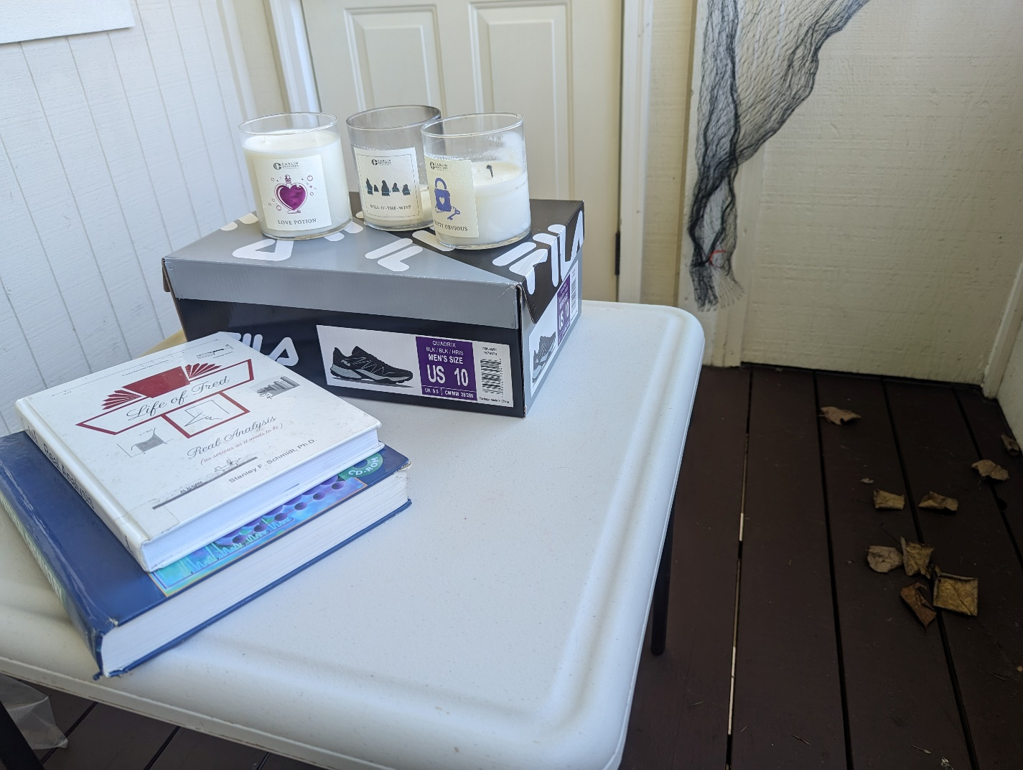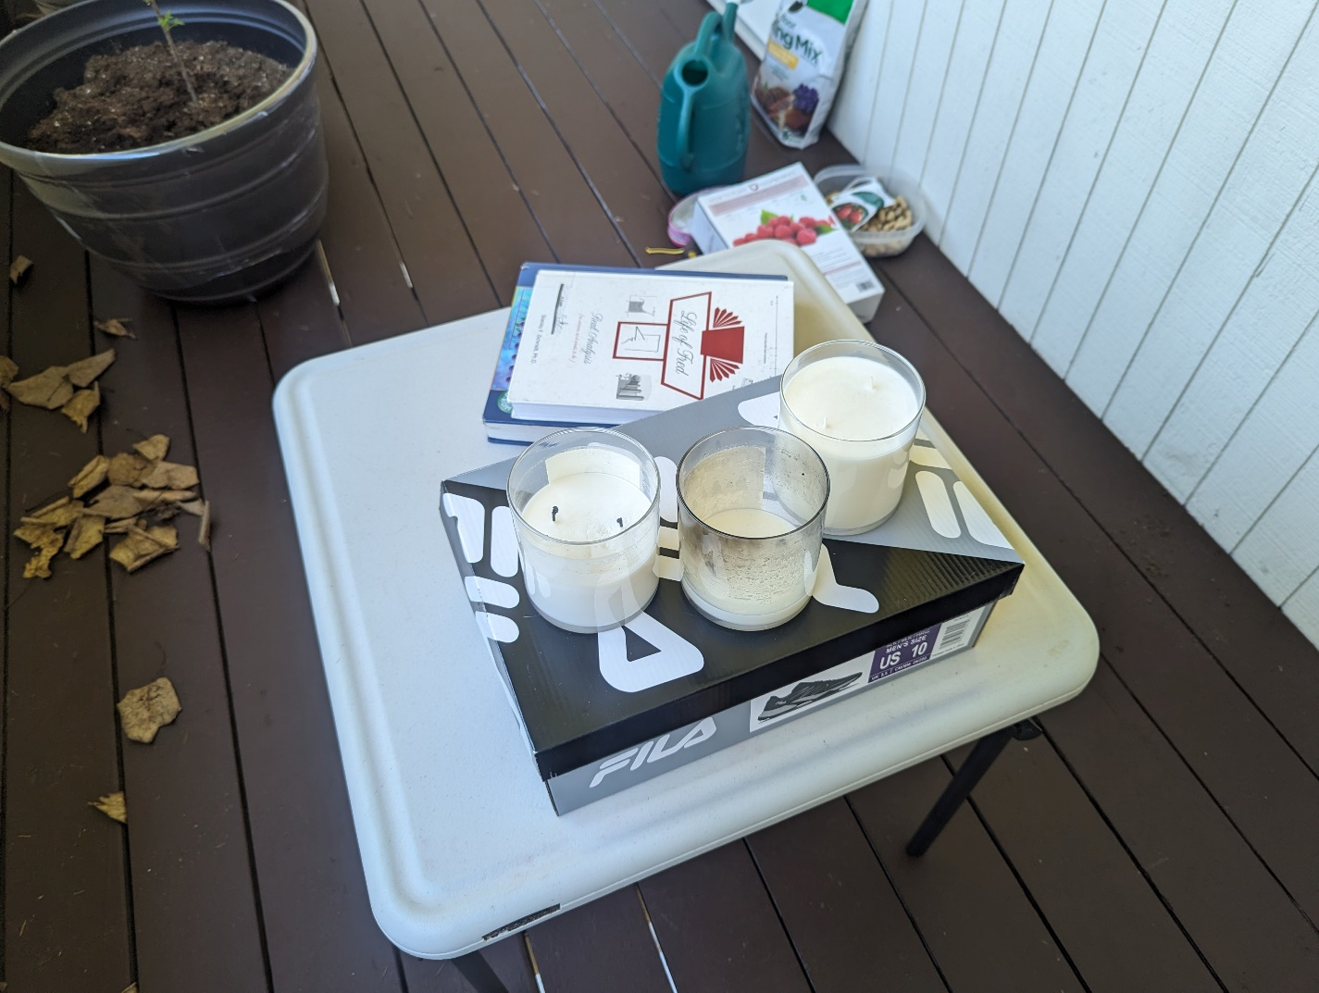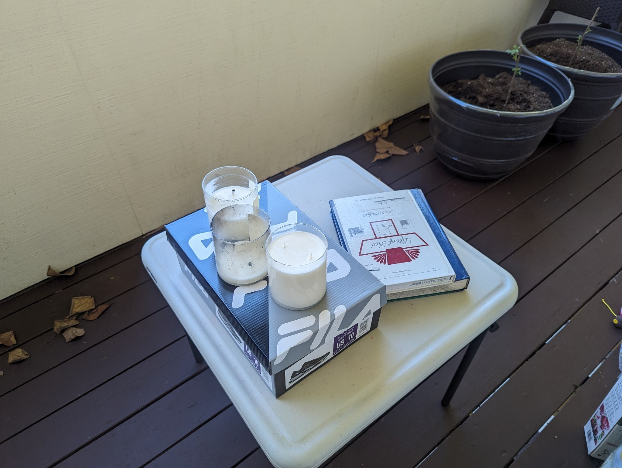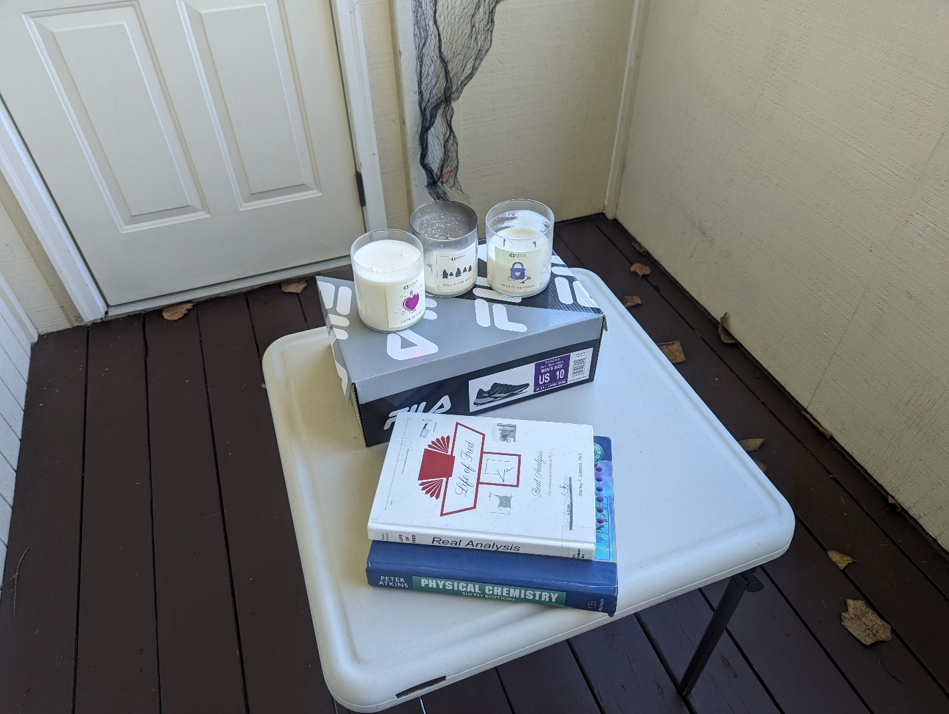

I set up my daughter’s table (a box with cylinders for legs) outside on my porch. I placed two books (more boxes) of various sizes on top of the table. I also placed a shoebox (a box with slightly larger box as the lid) on top of the table. I have some candles (a cylinder) that I thought would look nicer than they actually did when placed upon the table. I had candles of various heights in my head, but that wasn’t the case since I have nothing to raise one higher than the other.

I got this idea from the words “2D scenes that you might want to replicate in 3D”. Just like the last project my first thought of breaking this down was from art class breaking things down into their component geometric shapes. The first image that sprang to mind was a table with a bowl of fruit. Since I don’t have a bowl of fruit lying around, I figured a table with some candles and books would be fine. I may add something a little more complex since most of these are very basic shapes. I am uncertain exactly what I could add, but in my mind, it is missing something, maybe a basic plant.